**Entity Relationship Diagram**

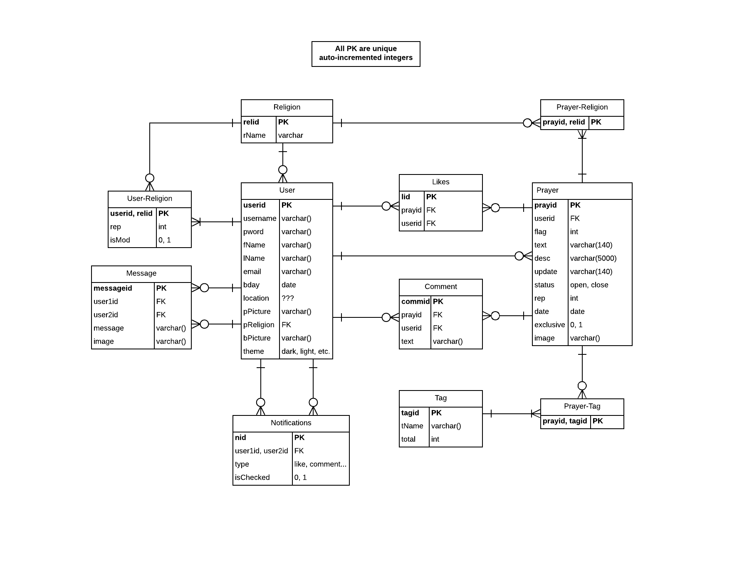

**Message**

**Example Data:**

|  |  |  |  |  |
| --- | --- | --- | --- | --- |
| **messageid** | **userid1** | **userid2** | **message** | **image** |
| 8675309 | 98992 | 24223 | ‘Pablo is great’ | null |

**1NF:**

There is no repeated data and all data is linked to a primary ID (messageid).

**2NF:**

All Data is dependent on the messageid and the messageid is required and unique. Each messageid can only have one of every other field.

**3NF:**

All fields are dependent only on the messageid. If any non-messageid field is changed, then it will not change any other field by default.

**Prayer**

Example Data:

|  |  |  |  |  |
| --- | --- | --- | --- | --- |
| **prayid** | **userid** | **flag** | **text** | **desc** |
| 124561 | 5442 | 2 | “Livin on a prayer” | “Descriptive material” |

|  |  |  |  |  |  |
| --- | --- | --- | --- | --- | --- |
| **update** | **status** | **rep** | **date** | **exclusive** | **image** |
| null | open | 12 | 09/06/2018 | 0 | null |

**1NF:**

None of the data is repeated and everything is dependent on the prayid.

**2NF:**

The Prayer table is in 1NF and everything is dependent on the prayid and the prayid is required an unique.

**3NF:**

The Prayer table is in 2NF All fields are dependent only on the prayid. If any non-prayeid field is changed, then it will not change any other field by default.

**Likes**

Example Data:

|  |  |  |
| --- | --- | --- |
| **lid** | **prayid** | **userid** |
| 21415 | 124561 | 5325 |

**1NF:**

None of the data is repeated and everything is dependent on the lid.

**2NF:**

The Likes table is in 1NF and everything is dependent on the lid and the lid is required an unique.

**3NF:**

The Likes table is in 2NF All fields are dependent only on the prayid. If any non-lid field is changed, then it will not change any other field by default.

**Tag**

Example Data:

|  |  |  |
| --- | --- | --- |
| **tagid** | **tname** | **total** |
| 00013 | Islam | 2390 |

**1NF:**

There are no repeating groups within the Tag table. All data is linked to the primary key, tagid

**2NF:**

The Tag table is in 1NF and all the attributes of the Tag table are dependent of the entire key. Since the key is not compound its not really possible for it to not be

**3NF:**

The Tag table is in 2NF and all the attributes within the Tag table are dependent only on the primary key, and not a non-key attribute

**Prayer-Tag**

Example Data:

|  |  |
| --- | --- |
| **tagid** | **prayid** |
| 00013 | 124561 |

**1NF:**

There are no repeating groups within the Prayer-Tag table. The primary key is a compound key made up of two foreign keys, the prayid field from the Prayer table and the tagid field from the Tag table.

**2NF:**

2NF: All attributes of the Prayer-Tag table are dependent of the entire key. Both parts of the key are necessary for each piece if data. The table is also in 1NF already

**3NF:**

3NF: In 2NF and all the attributes within the Prayer-Tag table are dependent only on the primary key.

**User**

**Example Data:**

|  |  |  |  |  |  |  |  |
| --- | --- | --- | --- | --- | --- | --- | --- |
| Userid | fname | lname | username | password | p-picture | b-picture | etc |
| 3142 | Pablo | Rivas | Reevus | 12345 | a2odef.jpg | kepdf3.jpg | ... |

**1NF:**

There is no repeating data in the User table. All data can be identified by the primary key Userid.

**2NF:**

All attributes are dependent on the primary key Userid, which is required and unique. The Userid can only have one of every field.

**3NF:**

All non-key fields are dependent only on the Userid. If a field is changed, it does not require any other field to change.

**User-Religion**

**Example Data:**

|  |  |  |  |
| --- | --- | --- | --- |
| **Userid** | **Relid** | Rep | isMod |
| 3142 | 2234 | 8232 | 1 |

**1NF:**

There is no repeating data in the User table. All data can be identified by the composite primary key Userid, Relid.

**2NF:**

All attributes are dependent on the composite primary key Userid, Relid which are both required and the combination of the two must be unique. A combination of Userid and Relid can only have one of every other field.

**3NF:**

All non-key fields are dependent only on the the combination of Userid, Relid. If isMod is changed it does not force Rep to be changed, and vice-versa.

**Comment**

**Example data:**

|  |  |  |  |
| --- | --- | --- | --- |
| **CommID** | **PrayID** | **UserID** | Text |
| 1236 | 1753 | 9534 | Pray for my son |

**1NF:**

No data is repeating, all data can be identified by the composite primary key, UserID, CommID, and PrayID.

**2NF:**

All attributes are dependant on the composite primary key, UserID, CommID, and PrayID, which are both required, and a unique combination.

**3NF:**

All non-key fields are dependant on the composite primary key.

**Notification**

**Example Data:**

|  |  |  |  |
| --- | --- | --- | --- |
| **Nid** | User1id, user2id | type | isChecked |
| 4653 | 4215,7646 | like | 1 |

**1NF:**

No data is repeating, and all data can be identified by the Nid.

**2NF:**

All attributes are dependant on a unique primary key.

**3NF:**

All non-key fields are dependant on the primary key. If isChecked is changed, no other field is forced to change.

**Prayer-Religion**

Example Data:

|  |  |
| --- | --- |
| **prayid** | **relid** |
| 124561 | 121 |

**1NF:**

There are no repeating groups within the Prayer-Religion table. The primary key is a compound key made up of two foreign keys, the prayid field from the Prayer table and the relid field from the Religion table.

**2NF:**

2NF: The table is also in 1NF. All attributes of the Prayer-Religion table are dependent of the entire key. Both parts of the key are necessary for each piece if data.

**3NF:**

3NF: In 2NF and all the attributes within the Prayer-Religion table are dependent only on the primary key.

**Religion**

Example Data:

|  |  |
| --- | --- |
| **relid** | **rName** |
| 121 | Christianity |

**1NF:**

There are no repeating groups within the Religion table. The primary key is relid.

**2NF:**

2NF: The table is also in 1NF. All attributes of the Religion table are dependent of the entire key. Since the key is not compound it is not possible to be dependent on only part.

**3NF:**

3NF: In 2NF and all the attributes within the Religion table are dependent only on the primary key.